Progressive Report

Return analysis group by trough date

Dingming

Key Takeaways:

1. The average return between day0-day20 is composed of (**70%** day0-day1 return + **30%** day1-day20 return). Day0-day1 return contributes the most.
2. The average return from trough to day20 is 5%-6%.
3. The average return of day x – 20 (x = 1, 2, 3…) is decreasing with x increase.

**Results:**

1.Situation Summary

  
Situation 1 takes up 1/3 of all beat situations and 2/3 of beat up situations.

2. Distribution of Trough Date

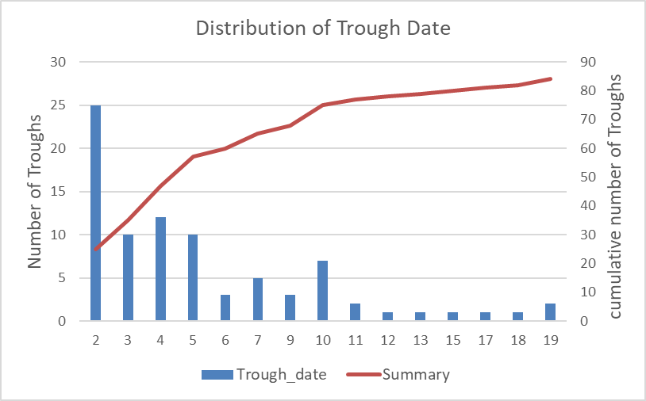



Trough is located the most on day 2. Troughs are likely to locate on Day0-5 and after Day 10 there is a very small amount of trough.

3. Return Analysis by trough/day20  
  
  


This result indicates that most of the return from day0-20 is contributed by the gain on day1 (an average of 6%). The return of holding from day0-day20 is higher than buy the stock at trough in stage. The result is grouped by trough date of 2-5, 6-10 and 2-10. The difference between groups is not significant

4. Average Return of buying on different dates and hold till day20



This table calculates average return from day x to day 20. The average return declines as the buying date increases.

The following tables are the returns of buy on day 2/5/10 and hold till day x.





